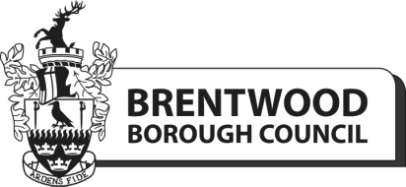

Risk Assessment Pro Forma Community Halls 2023

It is a requirement that a risk assessment is completed by each individual hall booking. Once you have completed the risk assessment, please return it to enquiries@brentwood.gov.uk

Please note that hirers are responsible for all their own equipment.

Guidance notes

When completing the Risk Assessment please identify any potential risks that you are aware of relating to your activity.
- Identify the general area of concern – e.g. trip hazard, falling
- Identify the particular Hazard– potential harmful ingredients such as nuts in the food.
- What are putting in place to minimise that hazard – e.g. labelling of all ingredients so that the public are aware
- Identify who would be at risk – i.e. the public, a contractor
- What is the worst outcome if this happens? e.g. injury, death
- What is the probability of this happening i.e. very likely, remote
- Do you consider this to be an acceptable risk at this time? – Yes or No
- If no what further actions will you be taking to further minimise this risk.

If you have any questions, please contact enquiries@brentwood.gov.uk 01277 312500

Risk Assessment – Community Halls 2023 – please complete the below with as much details as possible.

Name of organisation/booking name _________________________________________________________________________________________

Activity/Area of Concern | Hazard Identified | Existing Control Method | Person at risk | Worst Outcome | Probability | Acceptable risk at this time | Action Required
i.e Trip Hazards | Trailing cables | Cable protectors or tape to secure down cables | All (public and staff) | Major Injury | Possible | Yes | Ensure regularly checked throughout booking
Name of Organisation___________________________________________________________ Date completed______________________________________

