Internal use only
Comment No.
Ack. date
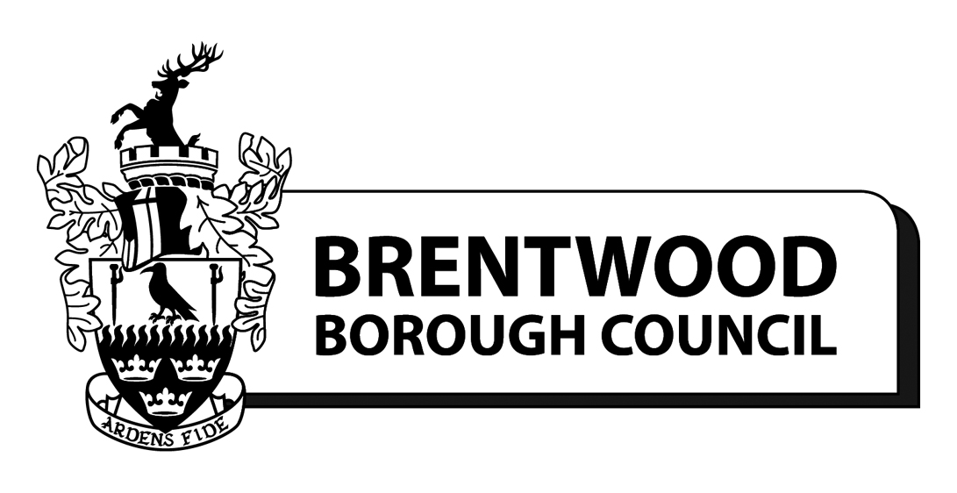

Brentwood Borough Local Plan
Strategic Growth Options Consultation
January 2015

Consultation questionnaire

This consultation questionnaire relates to the Brentwood Local Plan Strategic Growth Options Consultation and is provided for you to make comments. Please take the opportunity to read the consultation document before filling in this form and returning to:
Planning Policy Team, Brentwood Borough Council Town Hall, Brentwood, Essex, CM15 8AY
or by email to planning.policy@brentwood.gov.uk

Comments need to be received by 5pm on Tuesday 17 February 2015

If you need any help completing this form please contact the Planning Policy Team using the contact details given above or by telephoning 01277 312620.

Personal Details

Title: | First Name: |  | Last Name:
Organisation (if applicable):
Job title (if applicable):
Address:
Post Code: |  | Telephone Number:
Email Address:

Questions
The Council is seeking responses on key issues. Focused questions appear in bold boxes throughout the Strategic Growth Options document. These questions are summarised in this consultation questionnaire. More information can be found at www.brentwood.gov.uk/localplan.

Please use an additional sheet if necessary. Please note that all responses will be published online.

?  Q1: Do you agree with the broad areas, for the purpose of considering approaches to growth? | Yes | No
Comments

?  Q2: Do you agree with the issues raised within each of these areas? | Yes | No
Comments

?  Q3: Do you have any comments on the appropriateness of particular sites? | Yes | No
Comments

?
Q4: Given the greater capacity for growth along the A127 corridor, which of the sites put forward do you think is the best location for growth?
Comments

?  Q5: Should the A12 corridor accommodate growth by releasing sites on the edge of urban areas? | Yes | No
Comments

?
Q6: In order to provide for local need is it preferable for Greenfield sites on the edge of villages to be released, or to develop brownfield sites (both within the Green Belt)?
Comments

?  Q7: To enable future employment need to be met do you agree that the most sustainable approach is to allocate new sites close to the strategic highway network? | Yes | No
Comments

?  Q8: In order to ensure that the Town Centre remains economically sustainable, do you agree that a “Town Centre First” approach should be taken to retail development? | Yes | No
Comments

?  Q9: Are there opportunities for more open space provision in the area where you live? | Yes | No
Comments

?
Q10: Please rate the level to which you value the landscape near where you live (on a scale of 1 to 5), as compared to other areas within Brentwood Borough, for the following aspects:
Aspect: | Very Low | Low | Average | High | Very High
Scenic Beauty / Attractivness | 1 | 2 | 3 | 4 | 5
Outdoor Recreation / Leisure Use | 1 | 2 | 3 | 4 | 5
Wildlife Interest | 1 | 2 | 3 | 4 | 5
Historic Interest | 1 | 2 | 3 | 4 | 5
Tranquility | 1 | 2 | 3 | 4 | 5
Other – please specify:  ………………………………….. | 1 | 2 | 3 | 4 | 5

?
Q11: To what extent do you think the following are present in the landscape near where you live (on a scale of 1 to 4):
Aspect: | Absent | Occasional | Frequent | Predominant
Houses | 1 | 2 | 3 | 4
Commercial / Industrial buildings | 1 | 2 | 3 | 4
Nature Reserves / Wildlife | 1 | 2 | 3 | 4
Farmland | 1 | 2 | 3 | 4
Woodland | 1 | 2 | 3 | 4
Degraded / Derelict / Waste land | 1 | 2 | 3 | 4
Infastructure (Road / Rail / Pylons etc.) | 1 | 2 | 3 | 4
Leisure / Recreation Facilities | 1 | 2 | 3 | 4
Other – please specify:  ………………………………….. | 1 | 2 | 3 | 4

?  Q12: Have we considered the main infrastructure issues? Are there other important issues to consider? | Yes | No
Comments

?
Q13: What do you think the priorities for infrastructure spending should be?
Comments

Thank you for taking the time to complete this questionnaire

Please ensure that you return comments to the Council by 5pm on Tuesday 17 February 2015
(see page 1 for details)

